3- Circuit design which includes interfaces with the sensors, actuators and LCD .

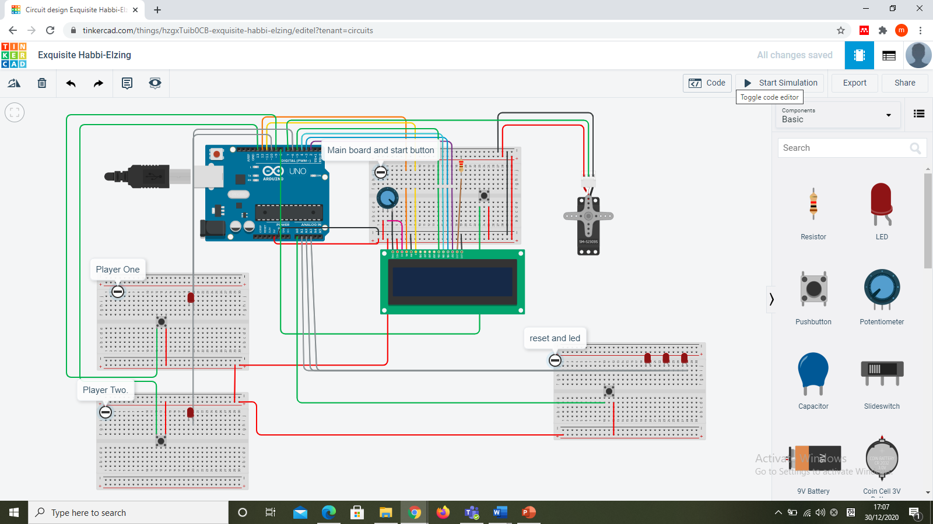

Firstly, the player can use the push button in the main board to start the game. After that we can start the push button for player one and player two to activate their board. Lastly if the player wants to rest and play again, they may push the reset button in the last board.

We use LCD, Arduino UNO, 5 LED, 4 Push buttons, 1 potential meter and Servo motor.